

**Compiler Construction**

**Assignment 1**

**Submitted by:**

* Talha Khalid
* F2021266625
* V-03
* Spring 2024
* BSCS

**Submitted to:**

Dr. Tayaba Anjum

1. **Environment Variable Set Up**

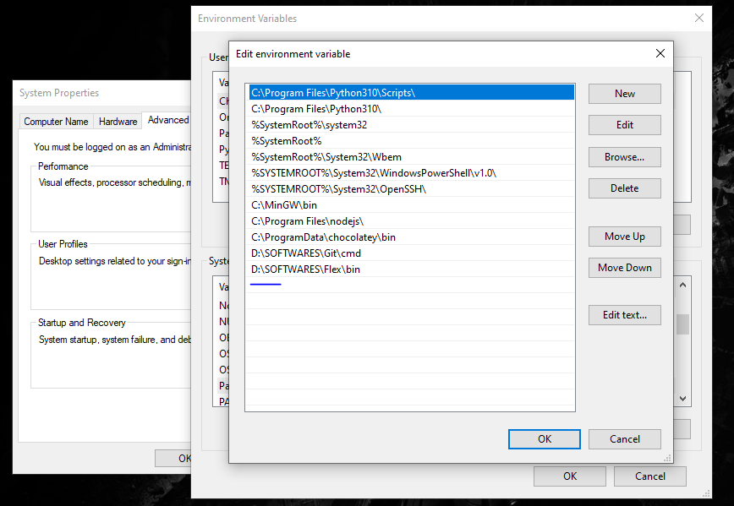

1. **Code**

%{

#include <stdio.h>

%}

%option noyywrap

letter [A-Za-z]

digit [0-9]

id {letter}({letter}|{digit}|_)*

digits {digit}{digit}*

%%

while |

if |

else |

return |

break |

continue |

int |

float |

void |

for |

printf {printf("keyword: %s\n", yytext);}

{letter}({letter}|{digit}|_)* {printf("Identifier: %s\n", yytext);}

{digits} { printf("Num: %s\n", yytext); }

{digits}\.{digits}?[Ee][+-]?{digits}?|\.{digits}[Ee][+-]?{digits}? { printf("Num: %s\n", yytext); }

"(" {printf("(: %s\n", yytext);}

")" {printf("): %s\n", yytext);}

"{" {printf("{: %s\n", yytext);}

"}" {printf("}: %s\n", yytext);}

"[" {printf("[: %s\n", yytext);}

"]" {printf("]: %s\n", yytext);}

"+" {printf("+: %s\n", yytext);}

"-" {printf("-: %s\n", yytext);}

"<" {printf("<: %s\n", yytext);}

">" {printf(">: %s\n", yytext);}

"<=" {printf("<=: %s\n", yytext);}

">=" {printf(">=: %s\n", yytext);}

"==" {printf("==: %s\n", yytext);}

"!" {printf("!: %s\n", yytext);}

"!=" {printf("!=: %s\n", yytext);}

"&&" {printf("&&: %s\n", yytext);}

"*" {printf("*: %s\n", yytext);}

"/" {printf("/: %s\n", yytext);}

"=" {printf("=: %s\n", yytext);}

.|\n {ECHO ;}

%%

int main(){

FILE *file = fopen("input.txt", "r");

FILE *file2 = fopen("output.txt", "w");

yyin = file;

yyout = file2;

yylex();

fclose(file);

fclose(file2);

return 0;

}

int my_wrap(){

return 1;

}

1. **Output.txt**

keyword: void

Identifier: main

(: (

): )

{: {

keyword: int

Identifier: sum

=: =

Num: 0

;

keyword: for

(: (

keyword: int

Identifier: j

=: =

Num: 0

; Identifier: j

<: <

Num: 10

; Identifier: j

=: =

Identifier: j

+: +

Num: 1

): )

{: {

Identifier: sum

=: =

Identifier: sum

+: +

Identifier: j

+: +

Num: 10

.Num: 43

+: +

Num: 34

Identifier: E4

+: +

Num: 45.34E-4

+: +

Identifier: E43

+: +

.Num: 34

}: }

}: }

1. **Running Commands**

